IMPACT ASSESSMENT REPORT
Project Title
Promotion of Health Care & Nutrition with Special Treatment to TB Patients in District Raebareli, Uttar Pradesh
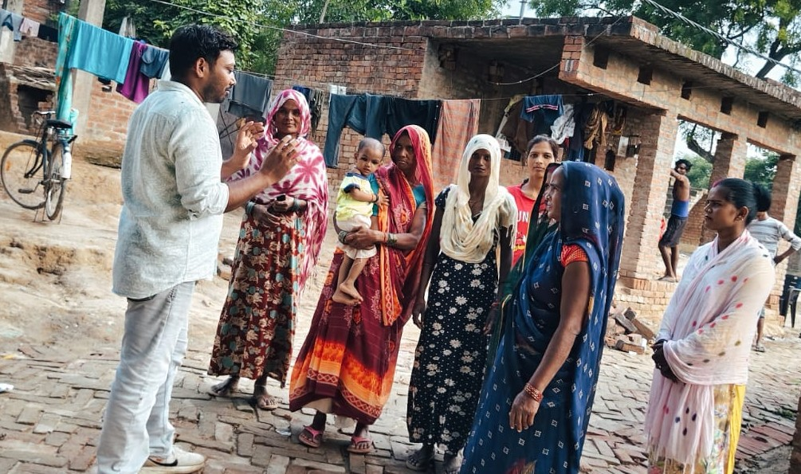
Supported By:  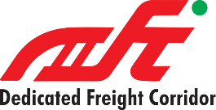  Dedicated Freight Corridor Corporation of India Limited (DFCCIL), New Delhi | 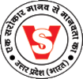  Submitted by:  Vishwas Sansthan  Raebareli, 229001 (U.P.)
Name of the Project: - Promotion of Health Care & Nutrition with Special Treatment to TB Patients in District Raebareli, Uttar Pradesh
Project Location: - District Raebareli (U.P.)

Project Details
Particular | Details
Project Duration | 22 March 2025 – 30 June 2025
Impact Assessment Period | 13 July 2025 – 19 July 2025
Project Area | Raebareli District, Uttar Pradesh
Target Beneficiaries | TB Patients
Total Nutrition Kits Distributed | 700
Implementing Agency | Vishwas Sansthan, Raebareli
CSR Partner | DFCCIL, New Delhi

Executive Summary
Tuberculosis (TB) remains one of India's major public health challenges, especially among economically weaker populations. Malnutrition is both a cause and consequence of TB, reducing immunity, delaying recovery, and increasing treatment failure. Recognizing this need, Dedicated Freight Corridor Corporation of India Limited (DFCCIL), under its Corporate Social Responsibility (CSR) initiative, partnered with Vishwas Sansthan to implement the project "Promotion of Health Care & Nutrition with Special Treatment to TB Patients" in Raebareli District.
The project was implemented between 22 March 2025 and 30 June 2025, during which 700 registered TB patients received specially designed nutrition kits. Awareness programmes, counselling sessions, and regular follow-up visits complemented the nutritional support to encourage treatment adherence and improve health outcomes.
An independent impact assessment was conducted from 13 July 2025 to 19 July 2025 to evaluate the project's effectiveness. The assessment found substantial improvements in nutritional intake, treatment compliance, awareness levels, and overall beneficiary well-being. Beneficiaries reported increased energy, reduced weakness, better appetite, and enhanced confidence in completing TB treatment.
The assessment confirms that the project successfully addressed immediate nutritional deficiencies while also strengthening community awareness and promoting healthier practices, making it a valuable contribution toward India's TB elimination goals.

1. Introduction
Tuberculosis is a communicable disease that primarily affects the lungs but can impact other organs as well. Despite the availability of free treatment under the National Tuberculosis Elimination Programme (NTEP), many patients experience delayed recovery because of inadequate nutrition and poor socio-economic conditions.
Patients from low-income families often struggle to consume balanced diets during treatment. Inadequate protein and calorie intake weakens immunity, prolongs recovery, and increases the likelihood of treatment interruption. Many TB patients are also unable to work regularly, resulting in reduced household income and worsening nutritional insecurity.
To address these challenges, DFCCIL supported a nutrition-focused intervention in Raebareli District. Vishwas Sansthan implemented the project in close coordination with the District Tuberculosis Office, Community Health Centres (CHCs), Primary Health Centres (PHCs), Arogya Mandirs, ASHA workers, and local health authorities.
The intervention combined nutritional support with awareness generation and continuous follow-up to improve treatment outcomes and quality of life for TB patients.

2. Purpose of the Impact Assessment
The primary purpose of this assessment was to determine whether the project achieved its intended objectives and to measure its impact on the health and well-being of TB patients.
The assessment specifically aimed to:
- Evaluate improvements in beneficiaries' nutritional status.
- Assess changes in treatment adherence and completion.
- Measure awareness regarding TB prevention, treatment, and nutrition.
- Examine beneficiary satisfaction with the project.
- Identify strengths, challenges, and opportunities for future CSR interventions.
- Generate evidence-based recommendations for scaling up similar programmes.

3. Objectives of the Project
The project was designed with the following objectives:
- Improve the nutritional status of TB patients through the distribution of quality nutrition kits.
- Support recovery and strengthen immunity during TB treatment.
- Increase awareness regarding tuberculosis, its symptoms, treatment, and prevention.
- Promote regular medication adherence.
- Reduce treatment default by encouraging continuous follow-up.
- Improve the overall quality of life of economically disadvantaged TB patients.
- Strengthen collaboration between community health systems and civil society organizations.

4. Methodology of Impact Assessment
The impact assessment adopted a mixed-method approach, combining quantitative and qualitative techniques to provide a comprehensive understanding of project outcomes.
Survey Period
13 July 2025 – 19 July 2025
Data Collection Methods
- Household visits
- Beneficiary interviews
- Focus Group Discussions
- Telephonic interviews
- Interaction with District TB officials
- Consultation with STS and ASHA workers
- Observation during follow-up visits
- Review of treatment records
- Review of project documentation
- Photo documentation
Stakeholders Consulted
- TB Patients
- Family Members
- District Tuberculosis Officer (DTO)
- Senior Treatment Supervisors (STS)
- Medical Officers
- ASHA Workers
- Community Leaders
- Project Staff

5. Sample Coverage
The assessment covered beneficiaries from all project locations across Raebareli district.
Indicator | Coverage
Total Beneficiaries | 700
Sample Surveyed | 210 (30%)
Blocks Covered | 10
Health Facilities Covered | 13
Health Officials Interviewed | 18
Community Health Workers | 26

The sample represented different age groups, genders, and socio-economic backgrounds to ensure balanced findings.

6. Assessment Criteria
The project was assessed using the following parameters:
- Relevance
- Effectiveness
- Efficiency
- Impact
- Sustainability
- Beneficiary Satisfaction
- Community Participation
- Institutional Coordination

7. Project Implementation Overview
The intervention included:
- Identification of eligible TB patients through the District TB Office.
- Procurement of standardized nutrition kits.
- Distribution of nutrition kits at CHCs, PHCs, Arogya Mandirs, and community centres.
- Health awareness meetings.
- Counselling on nutrition and medication adherence.
- Regular monitoring and follow-up.
- Documentation and reporting.
A total of 700 nutrition kits containing protein-rich and energy-dense food items were distributed across various health facilities in Raebareli district.

8. Findings of the Impact Assessment
A. Improvement in Nutritional Status
One of the most significant outcomes observed during the assessment was improved nutritional intake among beneficiaries.
Beneficiaries reported that the nutrition kits helped them consume healthier diets throughout the treatment period.
Observed improvements included:
- Increased daily calorie intake.
- Better protein consumption.
- Improved appetite.
- Reduced weakness.
- Better digestion.
- Gradual weight gain.
Approximately 91% of beneficiaries stated that the nutrition kit significantly improved their nutritional intake.

B. Improvement in Health Condition
Health workers reported visible improvements in the physical condition of many beneficiaries.
Common improvements included:
- Reduced fatigue.
- Better physical strength.
- Increased energy.
- Improved sleep.
- Reduced episodes of illness.
- Better capacity to perform daily activities.
Many beneficiaries resumed routine work after recovering from severe weakness.

C. Treatment Adherence
One of the project's strongest achievements was improved treatment adherence.
Continuous counselling motivated beneficiaries to:
- Take medicines regularly.
- Attend follow-up appointments.
- Complete prescribed treatment.
- Avoid treatment interruption.
Nearly 95% of surveyed beneficiaries reported that they completed or continued treatment without interruption.
Health officials also confirmed reduced default rates during the intervention period.

D. Awareness Generation
Awareness activities substantially increased community knowledge regarding TB.
Beneficiaries demonstrated improved understanding of:
- Early symptoms of TB.
- Importance of timely diagnosis.
- Infection prevention.
- Proper cough etiquette.
- Nutrition during treatment.
- Completing the full treatment course.
Many beneficiaries also shared the information with family members and neighbours, multiplying the project's impact.

E. Household Economic Relief
TB treatment often affects household income because patients are unable to work.
The nutrition kits reduced household expenditure on food, allowing families to redirect limited resources toward other essential needs such as education, transportation, and medicines.
Several families stated that the project significantly eased their financial burden.

9. Beneficiary Satisfaction
Overall satisfaction with the programme was very high.
Indicator | Satisfaction
Nutrition Kit Quality | 97%
Distribution Process | 96%
Staff Behaviour | 99%
Timeliness | 94%
Overall Programme | 97%
Beneficiaries appreciated:
- Quality of food items.
- Respectful behaviour of project staff.
- Transparent beneficiary selection.
- Coordination with health officials.
- Timely distribution.

10. Institutional Impact
The project strengthened coordination among:
- District Tuberculosis Office
- CHCs
- PHCs
- Arogya Mandirs
- ASHA Workers
- Community Volunteers
- Vishwas Sansthan
- DFCCIL CSR Team
This collaboration improved beneficiary identification, follow-up, and service delivery.

11. Success Story (Illustrative)
Mr. Pushkar Gupta., 25 years, Villiage Bandiyapur, Rahi Block, Raebareli
After being diagnosed with pulmonary TB, Mr. Pushkar Gupta experienced severe weakness, weight loss, and financial hardship. The nutrition kit provided through the DFCCIL-supported project enabled her to consume protein-rich foods regularly while continuing her prescribed treatment.
During the impact assessment visit, she reported increased energy, improved appetite, gradual weight gain, and renewed confidence in completing her treatment. She also shared awareness messages with other women in her village, encouraging early diagnosis and proper treatment.
His case demonstrates how nutritional support can positively influence treatment adherence and recovery.
12. Challenges
Although the project was successful, a few operational challenges were identified:
- Remote villages required additional travel time.
- Some beneficiaries migrated temporarily for work.
- Seasonal weather occasionally delayed distribution.
- Low literacy levels limited understanding of written IEC materials.
- Continued nutritional support beyond the project period remains a need for some vulnerable patients.

13. Lessons Learned
Key lessons emerging from the project include:
- Nutrition support significantly improves treatment adherence.
- Community-based distribution increases accessibility.
- Collaboration with government health systems enhances programme effectiveness.
- Counselling and follow-up are as important as nutritional assistance.
- CSR-supported health interventions can produce measurable public health outcomes when implemented through experienced local organizations.

14. Recommendations
To build on the project's success, the assessment recommends:
- Continue nutritional support for at least six months per patient.
- Introduce regular BMI and weight monitoring.
- Strengthen digital beneficiary tracking.
- Include family counselling sessions.
- Expand the programme to additional high-burden districts.
- Increase community awareness through village-level campaigns.
- Develop stronger convergence with NTEP and local health authorities.
- Establish periodic follow-up visits after treatment completion.

15. Conclusion
The impact assessment concludes that the Promotion of Health Care & Nutrition with Special Treatment to TB Patients project successfully achieved its intended objectives. The intervention improved nutritional intake, strengthened treatment adherence, enhanced awareness regarding tuberculosis, and reduced the economic burden on vulnerable households. The collaborative efforts of DFCCIL, Vishwas Sansthan, and the District Health Department ensured effective implementation and generated meaningful health outcomes.
The project serves as a commendable example of how CSR investments can complement government health programmes and create sustainable improvements in the lives of marginalized communities. With appropriate scaling and continued support, similar nutrition-based interventions can contribute significantly to India's goal of eliminating tuberculosis while improving the health, dignity, and resilience of affected families.

(Bipin Bajpai)
Secretary/Managing Director

